Fair trading is a practice existing since the early '40s but differently from how we mean it today. From the '80s, we had a shift in the fair trade area, from handmade products to an interest in human right and life standards.
Foundation such as the World Fair Trade Organization plays an essential role in fair trading around the globe.
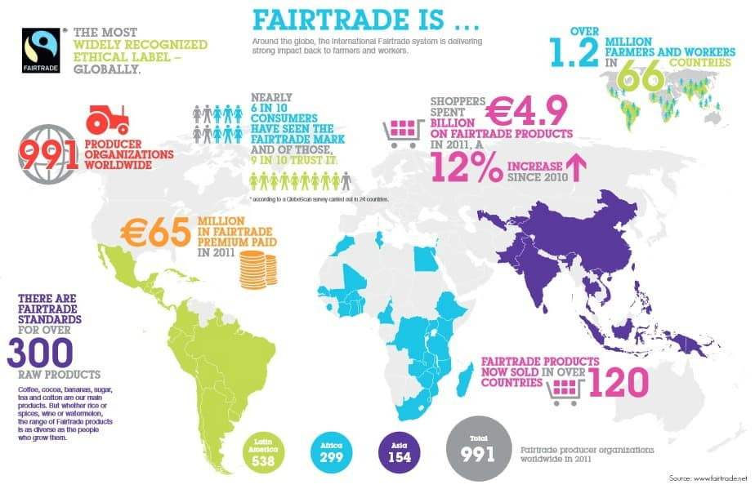

This is a picture from the Fair Trade official website and shows how widely they are spread around the globe. Another interesting point of view is the trust of consumers: 9 people out of 10, among who knows the brand, trust the ethical practice guaranteed by the Fair Trade logo.
Fair trade nowadays takes care of helping small producers, especially in essential sectors such as cocoa and coffee cultivation and refinement.
Speaking about prices, this means higher prices that come from a higher cost of production. Here we can clearly see both an advantage and a disadvantage. Even if farmers are never paid fewer than the minimum market price, they could face another problem: the higher rates could lead to a smaller demand in the market.
In my opinion, the most crucial benefit for producers is the so-called "fairtrade prize" that consists in giving producers an extra compensation constraint to a specific kind of expenditure, such as education, infrastructure or CAPEX for their activity.
Speaking about consumers is quite easy for them to find fair trade products. For example, in Italy, fair trade products could be found in every major supermarket.
A big problem with consumers is in the final distribution. in fact, fair trade organizations cannot control the final price of the product. Therefore it may happen that shopkeepers impose a very high markup given by the willingness to pay a higher rate of those who buy this type of product. The Fairtrade logo could be a plus for businesses like bar or restaurant because they could charge a higher price for what they sell.
Thanks to fair trade, which organizes farmers in cooperatives, these have significant benefits such as access to credit before harvesting and can sell their product without going through intermediaries. Another important thing is that in doing so, they also generate benefits for the environment reducing greenhouse for goods transportation.
The concept of fair trading brings with it a development problem. In other words, even if farmers take benefits for their work to spend on machinery for their activities, their development is strongly limited by the size of the local communities in which they have developed. This thing can be both a positive and a negative side. Economically speaking, it is a disadvantage because it prevents producers from growing in size and revenues, but humanly speaking, a strong presence in local communities can reduce poverty and generate a positive externality.
In conclusion, I hope that economist could fix the disadvantages to improve the expansion of this kind of business. I also hope that people who think that buying a product made in respect of fair-trading guidelines help only people in developing economies start purchasing these products because it is crucial for everyone, especially now that the world is turning in a "green" way.

